Here is a detailed description of all the functionalities in your **News Explorer** website:

**1. Header & Navigation Bar**

* The navigation bar is fixed at the top for easy access to different news categories.
* Includes the **company logo** (News Explorer) with a newspaper icon.
* Provides navigation links for categories: **Global, Finance, Politics, Technology, Sports, and Entertainment**.
* Includes a **search bar** where users can enter keywords to fetch news related to that topic.
* Uses Bootstrap Icons for **search functionality and category styling**.
* Clicking on a category fetches news related to that category from the **News API**.

**Functionalities:**

* **Clicking a navigation category (e.g., Finance, Technology, etc.)** calls fetchNews(category) to get relevant news.
* **Clicking the logo** reloads the page to show global news (reload() function).
* **Typing a keyword and clicking Search** calls fetchNews(query) to fetch related articles.

**2. Search Bar**

* Allows users to enter custom keywords for searching news articles.
* Clicking the search button triggers an API request to fetch related news.

**Functionalities:**

* **Takes input from the user**, constructs the API query, and fetches news articles.
* Removes active highlighting from any selected category.
* Displays search results dynamically in the news cards section.

**3. Carousel (Breaking News Section)**

* Displays **top trending breaking news articles** in a slider format.
* Fetches **5 breaking news headlines** dynamically from the News API.
* Uses left and right buttons to navigate between slides manually.
* Auto-scrolls every **5 seconds**.

**Functionalities:**

* **fetchCarouselNews("breaking news")** fetches trending news.
* **Dynamically binds the news articles** into the carousel using bindCarouselData(articles).
* Uses moveCarousel(direction) for left-right navigation.
* Uses startCarousel() for auto-scrolling every **5 seconds**.

**4. YouTube Video Section**

* Displays **3 YouTube videos** related to recent breaking news.
* Uses **iframe** elements to embed videos.

**Functionalities:**

* Uses pre-selected **YouTube video URLs**.
* Allows users to **watch breaking news updates directly from YouTube**.
* Supports full-screen mode.

**5. News Cards Section**

* Displays **news articles dynamically in card format**.
* Each news card contains:
  + **News image** (if available)
  + **Title of the article**
  + **Source & Published Date**
  + **Description**
  + **Like Button**
  + **Share Button**
  + **Comments Section**

**Functionalities:**

* **Fetching news:** Calls fetchNews(query) from the API and dynamically fills the news cards using bindData(articles).
* **Clicking on a news image:** Opens the full article in a **new tab**.
* **Liking an article:** Clicking the "Like" button triggers an **alert** confirming the like.
* **Sharing an article:** Clicking "Share" copies the **article URL** to the clipboard and shows an alert.
* **Adding comments:**
  + Users can type a comment and click "Post" to add it.
  + Pressing **Enter key** also submits the comment.
  + Newly added comments appear under the respective news card.

**6. Footer Section**

* Contains **social media icons** (Facebook, WhatsApp, Instagram, Twitter).
* Displays a copyright notice:  
  "© 2023 News Explorer. All rights reserved."

**Functionalities:**

* **Social media icons**: Currently, they are placeholders (#) but can be linked to social media pages.

**7. API Integration**

* The site fetches news using the **NewsAPI.org** service.
* **API Key:** "fc7928fa7f314b89b5291a0d337194d0"
* **Base URL:** "https://newsapi.org/v2/everything?q="

**Functionalities:**

* **Fetching general news:** fetchNews(query)
* **Fetching breaking news for carousel:** fetchCarouselNews("breaking news")
* **Binding fetched news to cards:** bindData(articles)
* **Binding fetched news to carousel:** bindCarouselData(articles)

**8. JavaScript Functionalities Overview**

**Global Functions**

| **Function** | **Description** |
| --- | --- |
| reload() | Reloads the page and fetches Global news. |
| fetchNews(query) | Fetches news based on category or search query. |
| fetchCarouselNews(query) | Fetches top 5 breaking news articles for the carousel. |
| bindData(articles) | Dynamically generates news cards. |
| bindCarouselData(articles) | Dynamically generates carousel items. |
| fillDataInCard(cardClone, article) | Fills a news card with data from an API response. |
| moveCarousel(direction) | Moves the carousel left or right. |
| startCarousel() | Auto-scrolls the carousel every 5 seconds. |
| onNavItemClick(id) | Highlights the selected category and fetches news. |

**9. User Interaction Features**

* **Category Navigation:** Click a category to fetch and display relevant news.
* **Search Functionality:** Type a keyword, press Enter or click Search to fetch news.
* **Carousel Navigation:** Auto-scroll and manual navigation with left/right buttons.
* **News Card Features:**
  + Click on the image to read the full news.
  + Like button to express appreciation.
  + Share button to copy the link.
  + Comment section for user engagement.

**10. Styling (CSS) Features**

**Color & Theme**

* Dark background with **radial gradient**.
* **Neon blue accents** for the navigation bar and buttons.
* Smooth hover effects and transitions.

**Typography**

* Uses **Poppins & Roboto** fonts for modern aesthetics.

**Responsiveness**

* Uses **Flexbox & Container classes** to ensure:
  + Proper alignment on different screen sizes.
  + Navigation, search bar, and carousel are mobile-friendly.

Screenshots: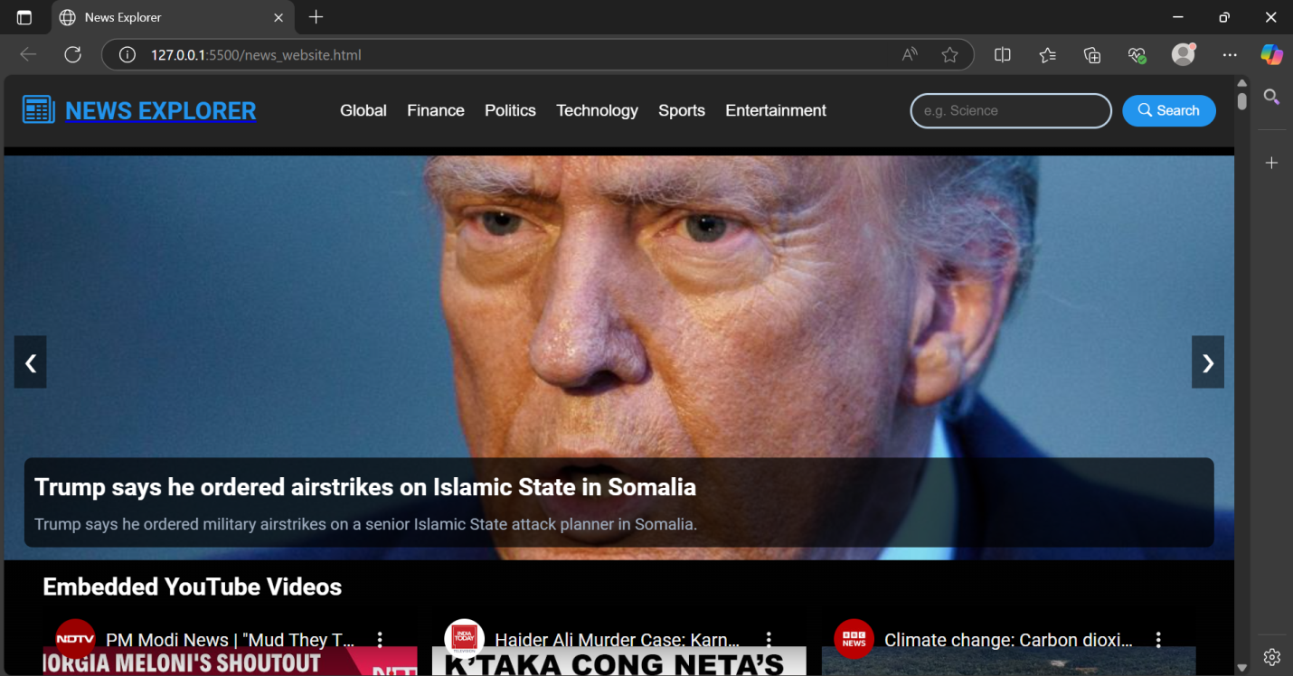

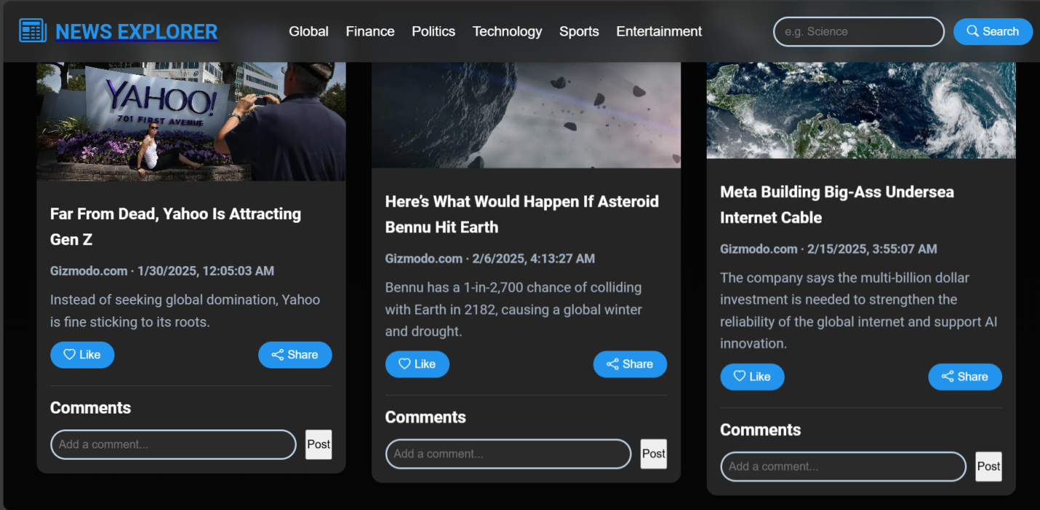

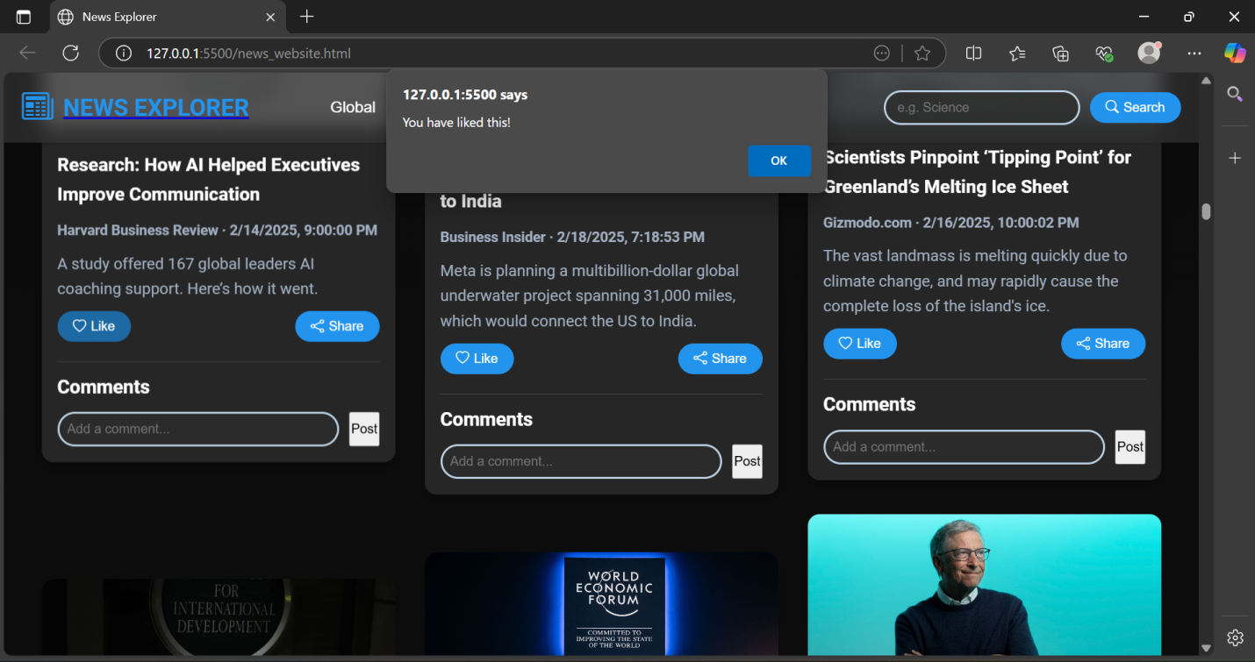

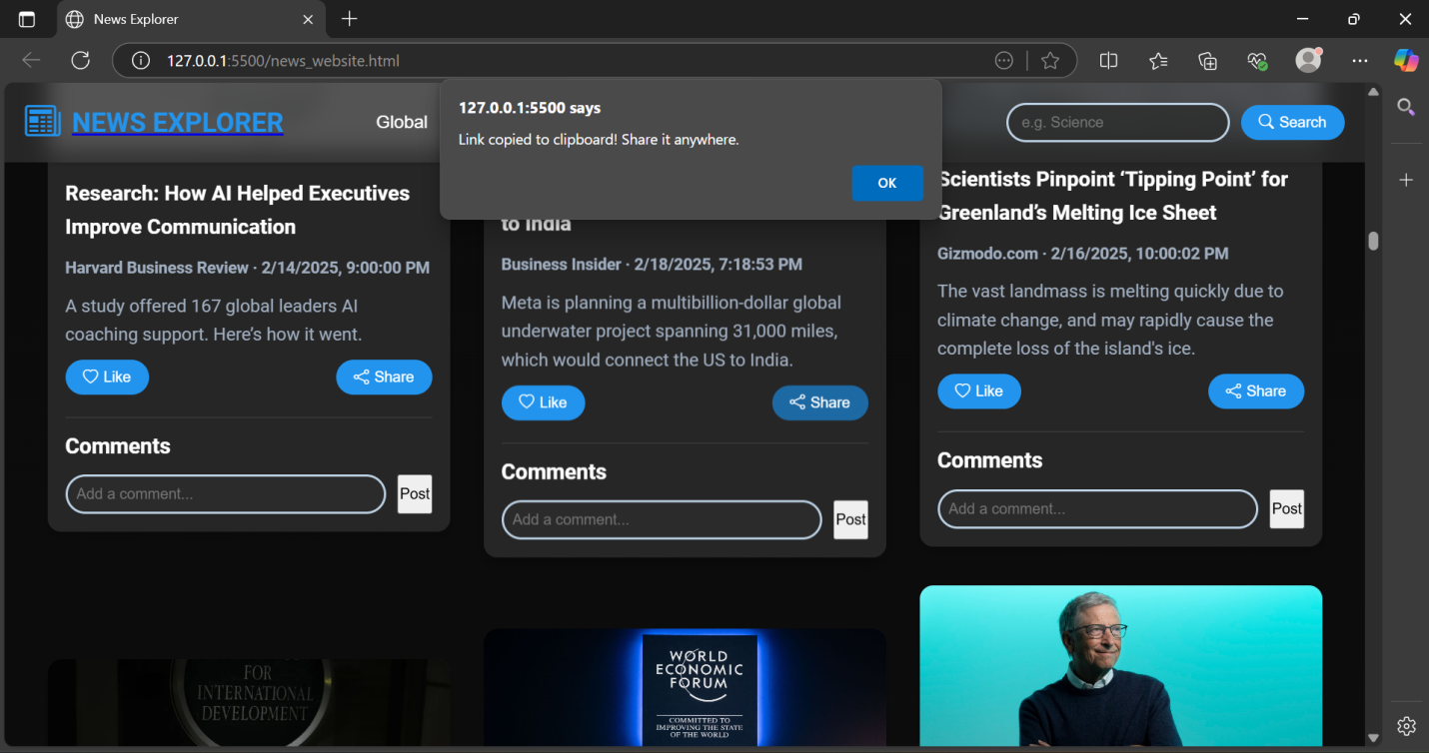

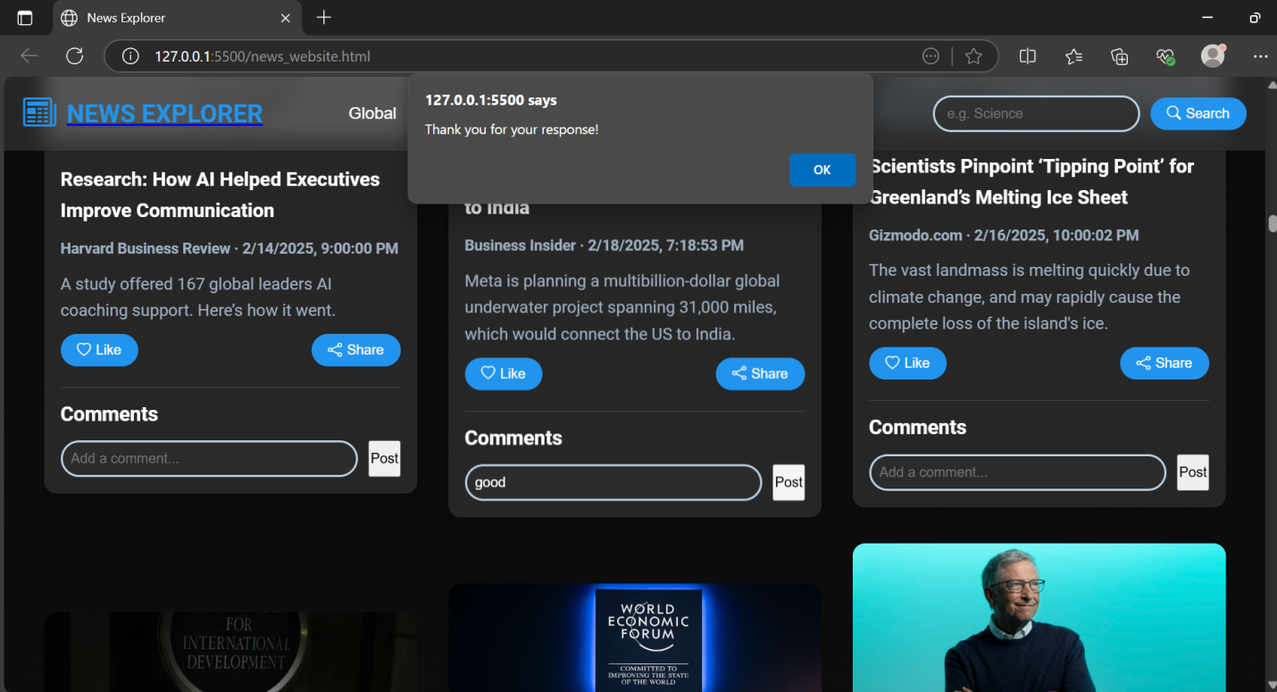

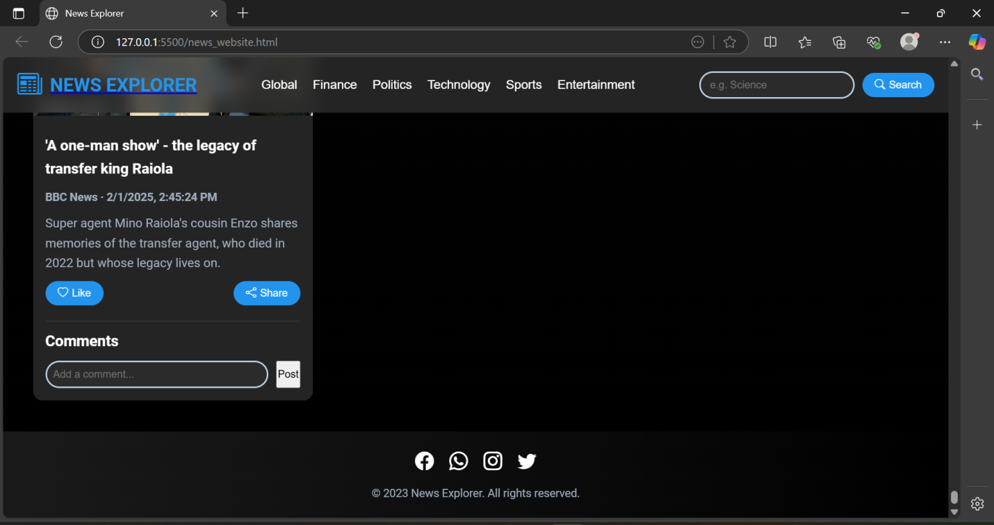

Sections…

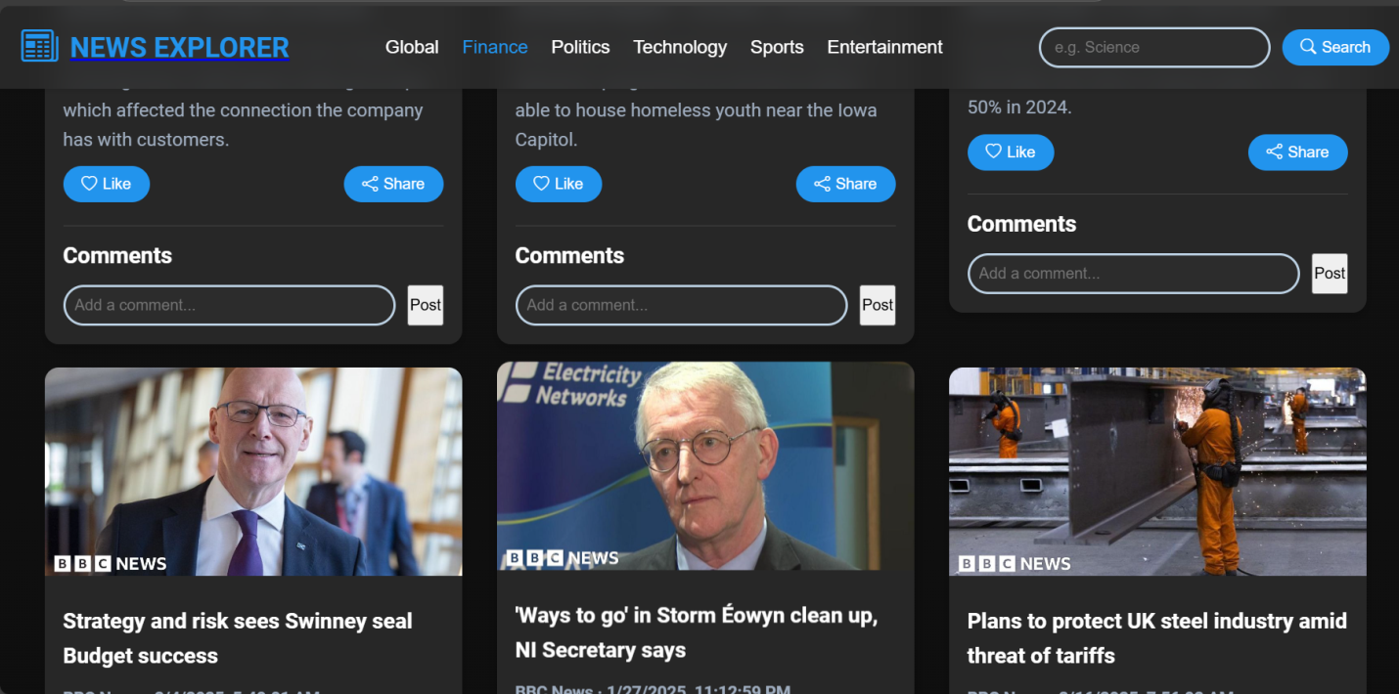

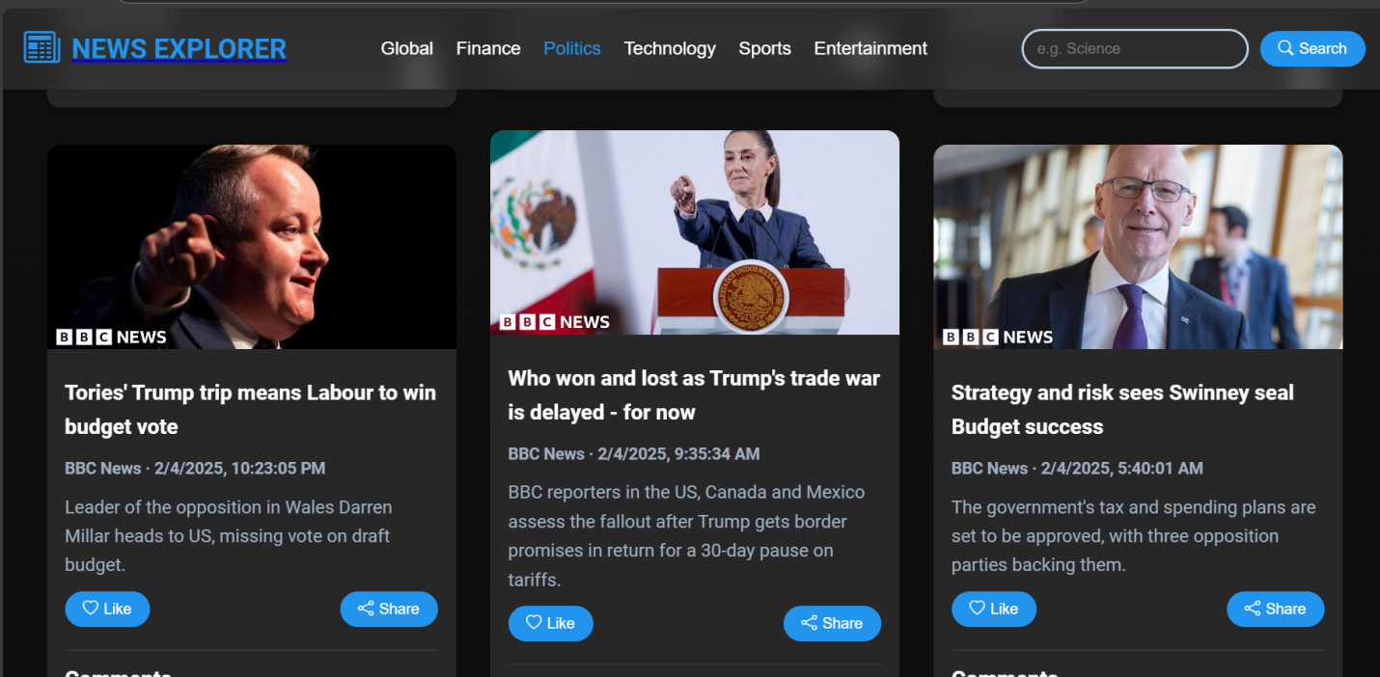

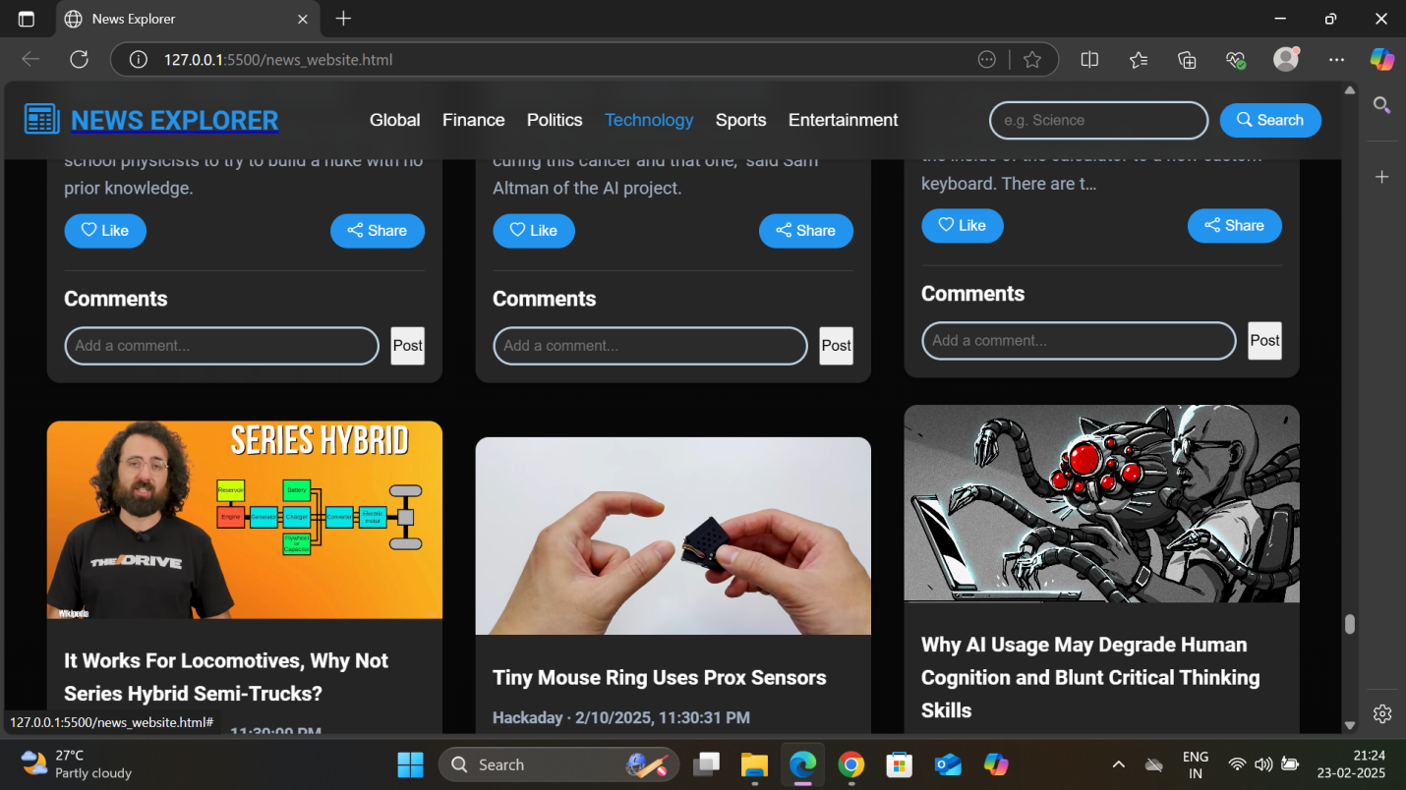

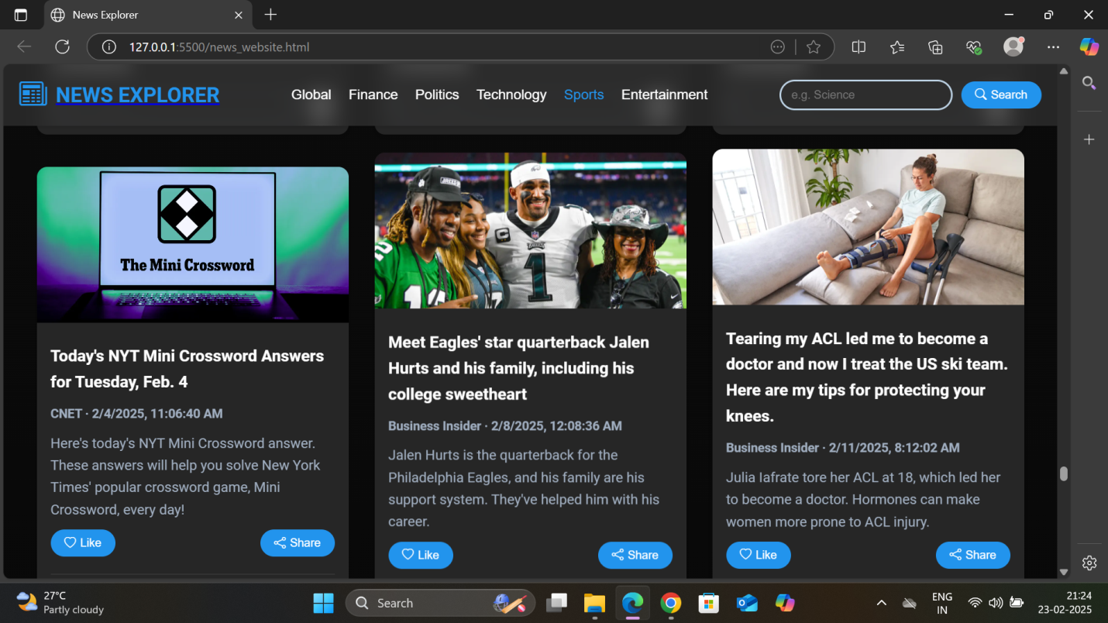

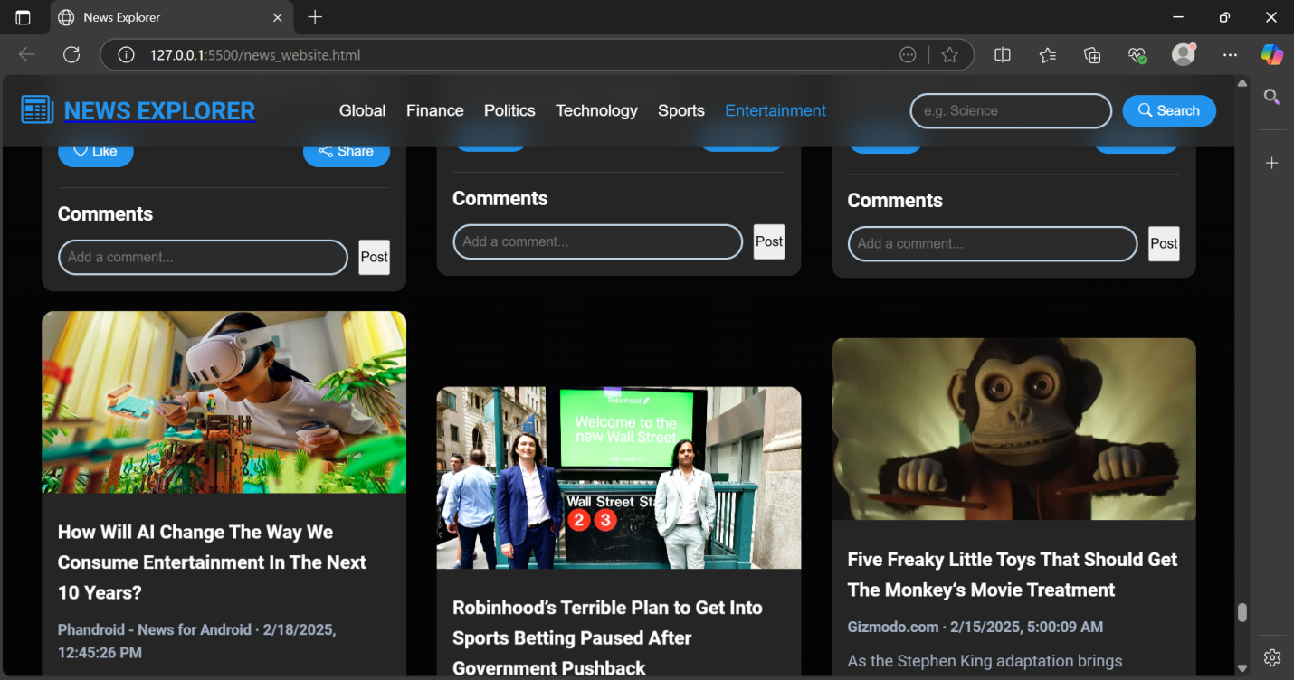

Search tab:

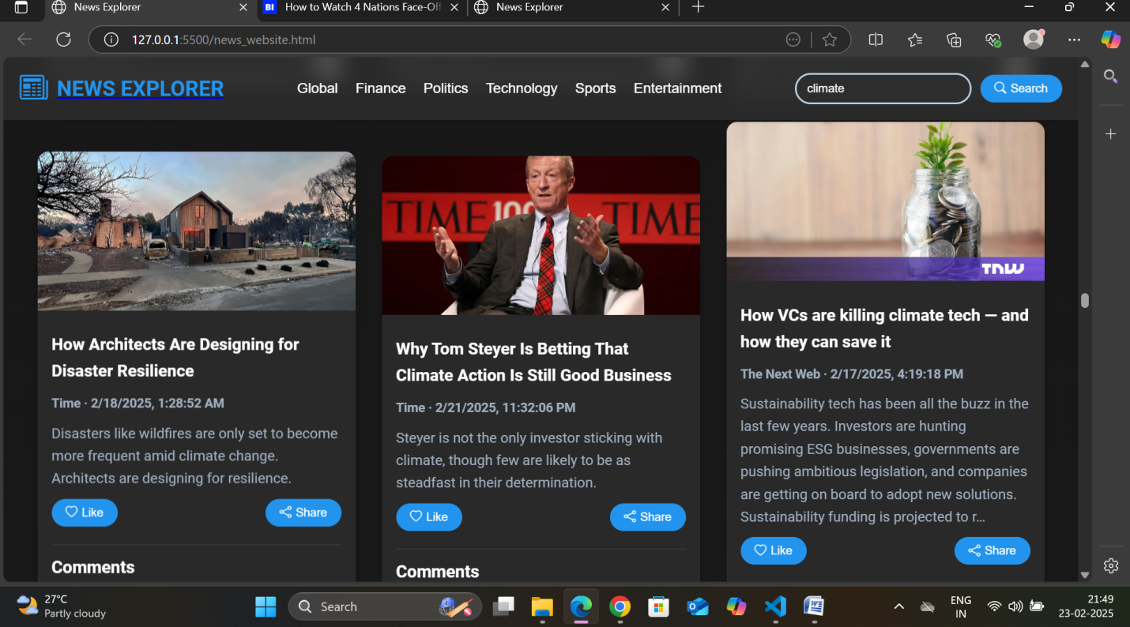

Mobile version

